**15.2**

1. Add

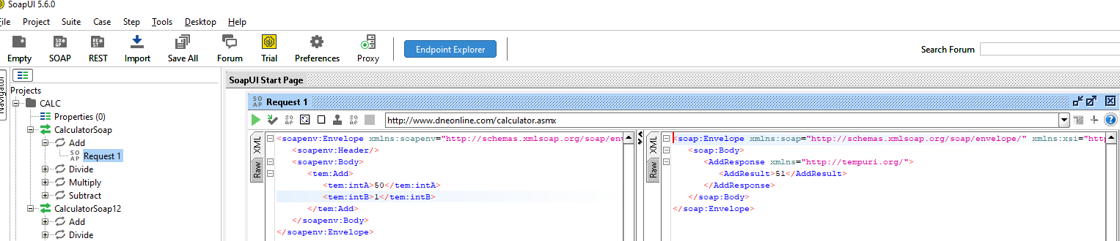

1. Multiply

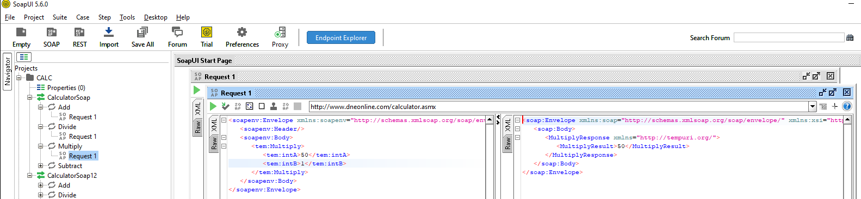

1. Subtract

